**INTERNSHIP** **AT INFOLABZ IT SERVICES PVT. LTD.**

**AN INTERNSHIP REPORT**

ON

**DYNAMIC WEB PAGE DESIGNING USING REACT JS**

*Submitted by*

**Modi Khushi Jagdishbhai**

**(200390116013)**

**In partial fulfillment for the award of the degree of**

**BACHELOR OF ENGINEERING**

In

**Information Technology Department**

**S.P.B. Patel Engineering College, Mehsana**

**Gujarat Technological University, Ahmedabad**

**August, 2023**



**S.P.B. Patel Engineering College**

**Near Shanku’s Water Park, Ahmedabad – Mehsana Highway, Linch, Gujarat**

**CERTIFICATE**

This is to certify that the project report submitted along with the project entitled Internship at **INFOLABZ IT SERVICES PVT. LTD.** has been carried out by **Modi Khushi Jagdishbhai** under my guidance in partial fulfilment for the degree of Bachelor of Engineering in Information Technology Engineering, 7th Semester of Gujarat Technological University, Ahmedabad during the academic year 2023-24.

Prof. Prof. Akshay Kansara

Internal Guide Head of Department



**CONFIRMATION LETTER**

**CERTIFICATE OF COMPLETION**







**S.P.B. Patel Engineering College, Mehsana**

**Near Shanku’s Water Park, Ahmedabad – Mehsana Highway, Linch, Gujarat**

**DECLARATION**

I do declare that the Internship report submitted along with the Internship entitled on **Dynamic web page designing using Reactjs at INFOLABZ IT SERVICES PVT. LTD.** submitted in partial fulfillment for the degree of Bachelor of Engineering in **Information Technology Engineering** to Gujarat Technological University, Ahmedabad.

I hereby warrant that the work I have presented does not breach any existing copyright acts.

Name of the Student Sign of Student

Khushi Modi _______________



**COMPANY PROFILE**

Established in 2016, incorporation with our parent IT company, INFOLABZ IT SERVICES PVT. LTD. has managed to make its own position in IT Sector. We are involved in Web Development, App Development, Progressive Web Application Development, IOT solutions, Graphics & Designing, Digital Marketing, Domain & Hosting services, SMS services etc.

In the span of seven years, we have managed to deliver all projects on time with utmost accuracy to our clients across the globe. We have dedicated teams of experienced and hard-working developers. Our developers who are always willing to take new challenges and looking forward to learn new things, are heart of this company.

Our objective is to sustain with exponential growth in IT industry. Our mission is to deliver the best with top notch quality every quarter and vision is to develop a product with one of its kind concepts which could be used by millions of people.

**ACKNOWLEDGMENT**

The internship experience I had with INFOLABZ IT SERVICES PVT. LTD. was truly invaluable, providing me with a remarkable opportunity for learning and professional growth. I consider myself extremely fortunate to have been given this chance.

I would like to express my sincere gratitude to Mr. Chintan Nagrecha, the director and instructor at INFOLABZ IT SERVICES PVT. LTD., for his guidance and mentorship throughout my internship. His insights and expertise were instrumental in shaping my learning experience. Additionally, I extend my heartfelt thanks to Ms. Zarana Shah, the HR professional at INFOLABZ IT SERVICES PVT. LTD., for her support and assistance.

This internship has marked a significant milestone in my career development, offering me a platform to acquire valuable skills and knowledge. I am committed to applying these newly acquired abilities in the most effective manner, while continuously striving to enhance and refine them. My dedication is geared towards achieving my ultimate career objectives.

**Abstract**

This internship will focus on dynamic webpage design using the popular React JavaScript framework, a crucial component of full stack web development. We will explore the significance of Application Programming Interfaces (APIs) as essential data sources, working with live APIs to create real-time dynamic web pages. The internship will cover key concepts such as HTTP's request-response mechanism and ES6, enabling us to fetch and integrate live data effectively. Through hands-on experience, we aim to master the art of crafting engaging and responsive web pages that reflect real-time information.

**List of Figures**

Fig 1.1 Object.html..........................................................................................................................2

Fig 1.2 Output..................................................................................................................................2

Fig 2.1 Functions.html…………………………………………………………………………….4

Fig 2.2 Output……..........................................................................................................................4 Fig 2.3 Arrowexample.html.............................................................................................................5

Fig 2.4 Output..................................................................................................................................5

Fig 2.5 Asyncfun.html.....................................................................................................................6

Fig 2.6 Output..................................................................................................................................6

Fig 3.1 Coviddata.html....................................................................................................................7

Fig 3.2 Output..................................................................................................................................8

Fig 3.3 Pop-upbox.html...................................................................................................................9

Fig 3.4 Output................................................................................................................................10

Fig 3.5 Formtovariable.html..........................................................................................................11

Fig 3.6 Output................................................................................................................................11

Fig 4.1 Formtotable output............................................................................................................13

Fig 4.2 Array output.......................................................................................................................14

Fig 5.1 Covid data search output...................................................................................................16

Fig 5.2 Mutual fund API output.....................................................................................................17

Fig 6.1 First React App..................................................................................................................19

Fig 6.2 Output................................................................................................................................19

Fig 6.3 Functional Component......................................................................................................20 Fig 6.4 Functional Component......................................................................................................21

Fig 6.5 Output................................................................................................................................21

Fig 7.1 Map....................................................................................................................................22

Fig 7.2 Output................................................................................................................................23

Fig 7.3 Object Map........................................................................................................................25

Fig 7.4 Output................................................................................................................................25

Fig 8.1 React Props........................................................................................................................26

Fig 8.2 Output................................................................................................................................27

Fig 8.3 React Bootstrap..................................................................................................................28

Fig 8.4 Output................................................................................................................................29

Fig 9.1 Fetch Politics Data.............................................................................................................32

Fig 9.2 Output................................................................................................................................33

Fig 10.1 Sports Data Output..........................................................................................................36

**TABLE OF CONTENT**

|  |  |  |
| --- | --- | --- |
| **WEEK / DAY NO** | **CONTENT** | **PAGE NO** |
|  | **Confirmation Letter** | **I** |
|  | **Completion Certificate** | **II** |
|  | **Declaration** | **III** |
|  | **Company Profile** | **IV** |
|  | **Acknowledgment** | **V** |
|  | **Abstract** | **VI** |
|  | **List of Figures** | **VII** |
|  |  |  |
| **WEEK 1 / Day 1** | **27 JULY 2023** | **1** |
|  | * INTRODUCTION TO JS |  |
|  | * INTRODUCTION TO ES6 |  |
|  | * OBJECTS |  |
|  |  |  |
| **WEEK 1 / Day 2** | **28 JULY 2023** | **3** |
|  | * JS Functions & Arrow Functions |  |
|  | * Async Function |  |
|  | * Bitcoin API |  |
|  |  |  |
| **WEEK 1 / Day 3** | **31 JULY 2023** | **7** |
|  | * Covid API – Data fetching and mapping |  |
|  | * USER INPUT 1 : JS Pop Up Boxes |  |
|  | * USER INPUT 2 : Form to Variable |  |
|  |  |  |
| **WEEK 1 / Day 4** | **01 AUGUST 2023** | **12** |
|  | * Form to table |  |
|  | * JS Arrays |  |
|  |  |  |
| **WEEK 1 / Day 5** | **02 AUGUST 2023** | **15** |
|  | * Task Assignment |  |
|  | * Covid Data Search |  |
|  | * Mutual Fund API |  |
|  |  |  |
| **WEEK 2 / Day 6** | **03 AUGUST 2023** | **18** |
|  | * React Environment setup (Node JS installation) |  |
|  | * First React App |  |
|  | * Functional Components |  |
|  | * Class Components |  |
|  |  |  |
| **WEEK 2 / Day 7** | **04 AUGUST 2023** | **22** |
|  | * Variable Data Map |  |
|  | * Object Map |  |
|  |  |  |
| **WEEK 2 / Day 8** | **07 AUGUST 2023** | **26** |
|  | * React Props |  |
|  | * React Bootstrap |  |
|  |  |  |
| **WEEK 2 / Day 9** | **08 AUGUST 2023** | **30** |
|  | * React Hooks : UseEffect and UseState |  |
|  | * API data fetch with react |  |
|  |  |  |
| **WEEK 2 / Day 10** | **09 AUGUST 2023** | **34** |
|  | * ASSIGNMENT TASK |  |
|  | * API BASED REAL TIME NEWS WEB APPLICATION |  |
|  |  |  |
| **WEEK 2 / Day 11** | **10 AUGUST 2023** | **37** |
|  | * Project & conclusion |  |

**WEEK 1: 27 JULY 2023**

**INTRODUCTION TO JS**

* JavaScript (JS) is a programming language used for making websites interactive and dynamic.
* It runs in web browsers, helping create animations, forms, and real-time updates.
* It works with variables, functions, and events. It can modify webpage content (DOM) and handles user actions.
* JavaScript is versatile, has libraries/frameworks, and can also run on servers using Node.js.
* It's crucial for modern web development.

**INTRODUCTION TO ES6**

* ES6 (ECMAScript 2015) is a major update to the JavaScript programming language.
* It introduced new features and improvements to make code more concise, readable, and efficient.
* Some key ES6 features include arrow functions, template literals, `let` and `const` for variable declarations, classes for object-oriented programming, enhanced object and array handling, and more.
* It modernized JavaScript and enhanced its capabilities for developers.

**OBJECTS**

* In JavaScript, objects are fundamental data structures that store key-value pairs.
* They are used to represent real-world entities or concepts.
* Objects can hold various data types and functions, making them versatile for creating complex structures and behaviors.
* Properties are accessed using dot notation (`object.property`) or bracket notation (`object['property']`).
* Objects play a crucial role in JavaScript for organizing and manipulating data in a structured manner.

**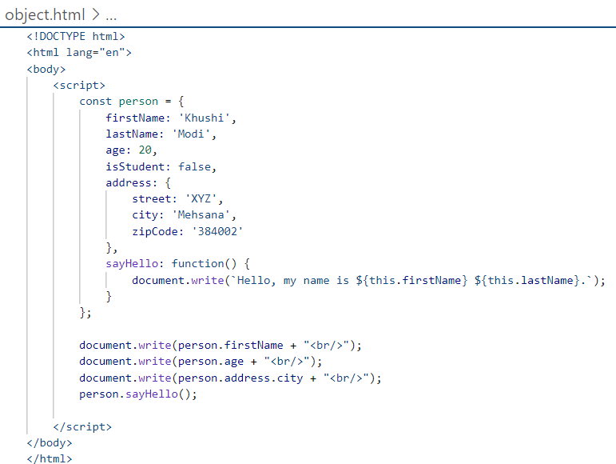****Fig1.1 Object.html**

**Output:**

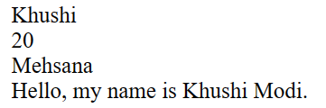

**Fig1.2 Output**

**WEEK 1: 28 JULY 2023**

**JS Functions & Arrow Functions**

* **JavaScript functions** are blocks of code that perform specific tasks and can be reused throughout your program.
* They help organize code and make it more modular. Functions are defined using the `function` keyword, followed by a name, parameters, and a block of code.
* **Arrow functions**, introduced in ES6, provide a more concise syntax for defining functions.
* They are especially useful for short, inline functions. Arrow functions omit the `function` keyword and use a simplified syntax, making the code cleaner.

Example of a regular function:

function add(a, b) {

return a + b;

}

Example of an arrow function:

const add = (a, b) => a + b;

* Arrow functions also handle the `this` keyword differently, using the lexical context of where they are defined.
* They're a convenient way to write compact functions in JavaScript.

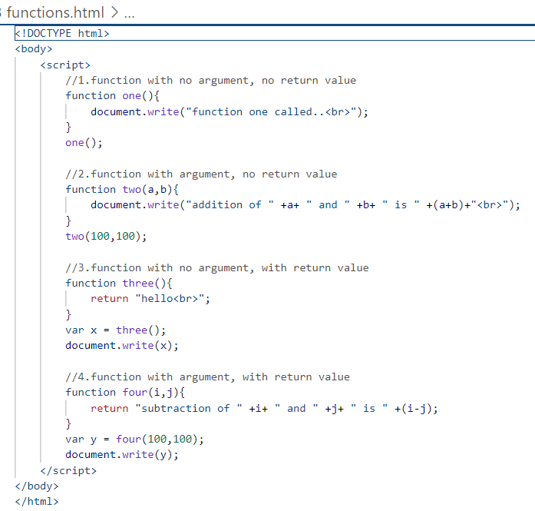

**Fig2.1 Functions.html**

**Output:**

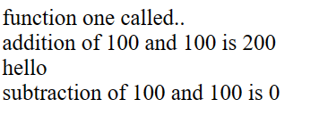

**Fig2.2 Output**

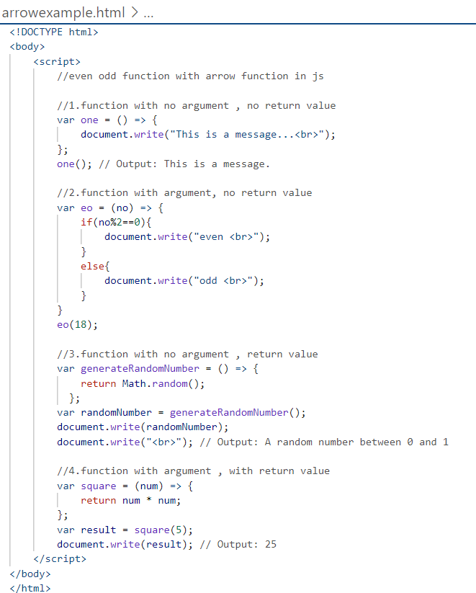 **Fig2.3 Arrowexample.html**

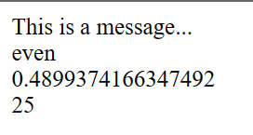**Output :**

**Fig2.4 Output**

**Async Function**

* An async function in JavaScript is a function that allows you to write asynchronous code using a more readable and sequential syntax.
* It uses the `async` keyword before the `function` keyword and the `await` keyword to pause execution until promises are resolved.
* This simplifies handling asynchronous operations and error handling, making your code look and behave more like synchronous code.
* Async functions return promises and are a powerful tool for managing asynchronous tasks in a more intuitive way.

**Syntax :**

async function fetchData() {

// Asynchronous code

}

**Example:**

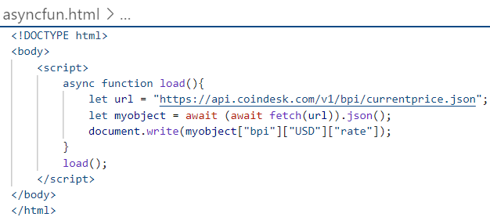**Bit-Coin API**

**Fig2.5 Asyncfun.html**

**Output:**

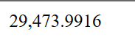

**Fig2.6 Output**

**WEEK 1: 31 JULY 2023**

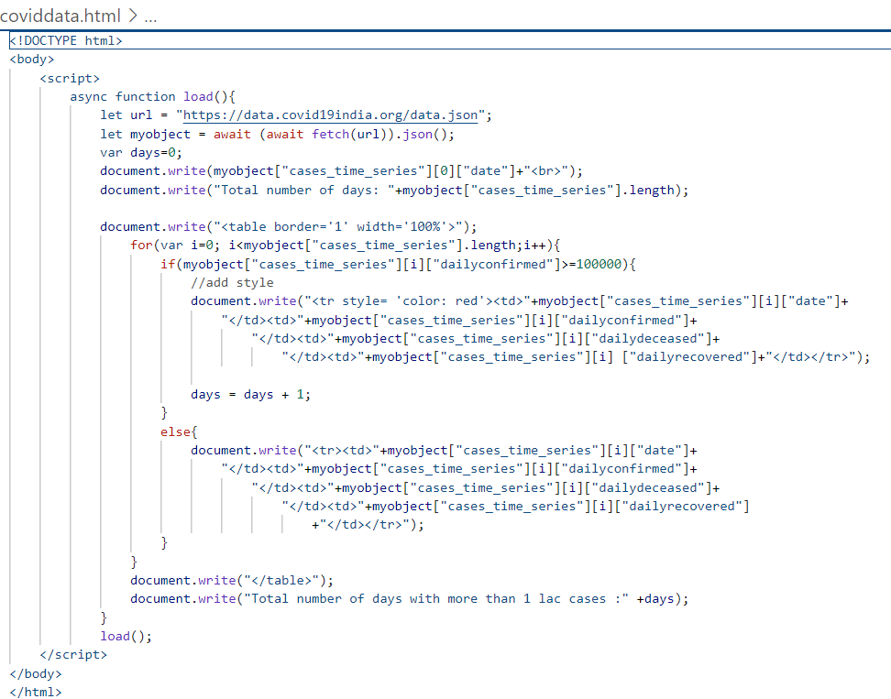**Covid API – Data fetching and mapping**

**Fig3.1 Coviddata.html**

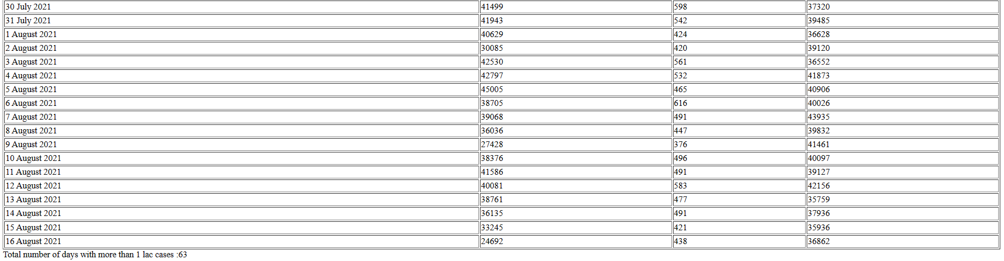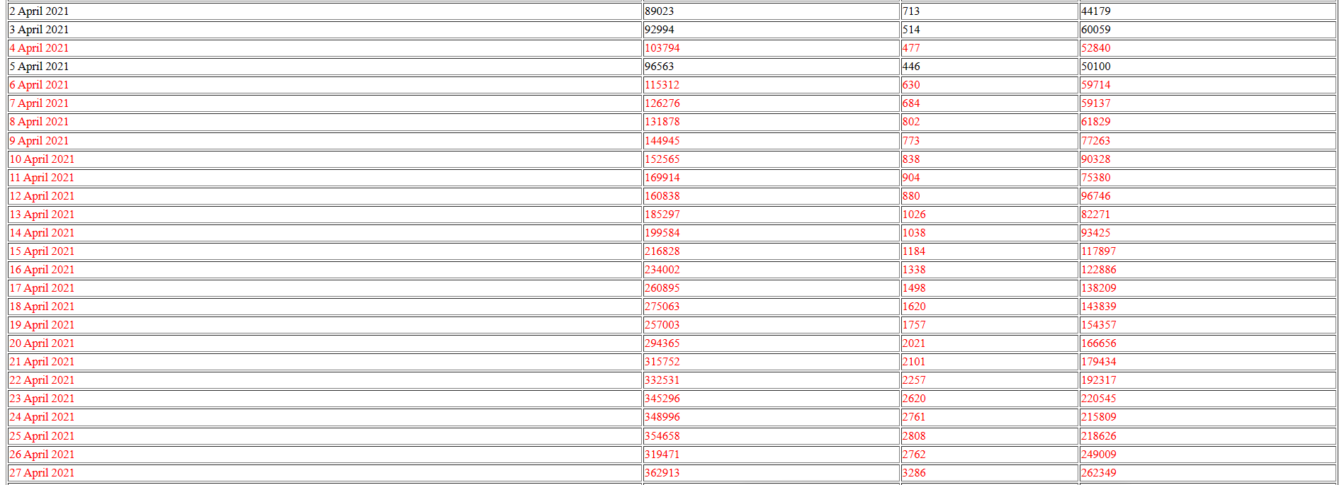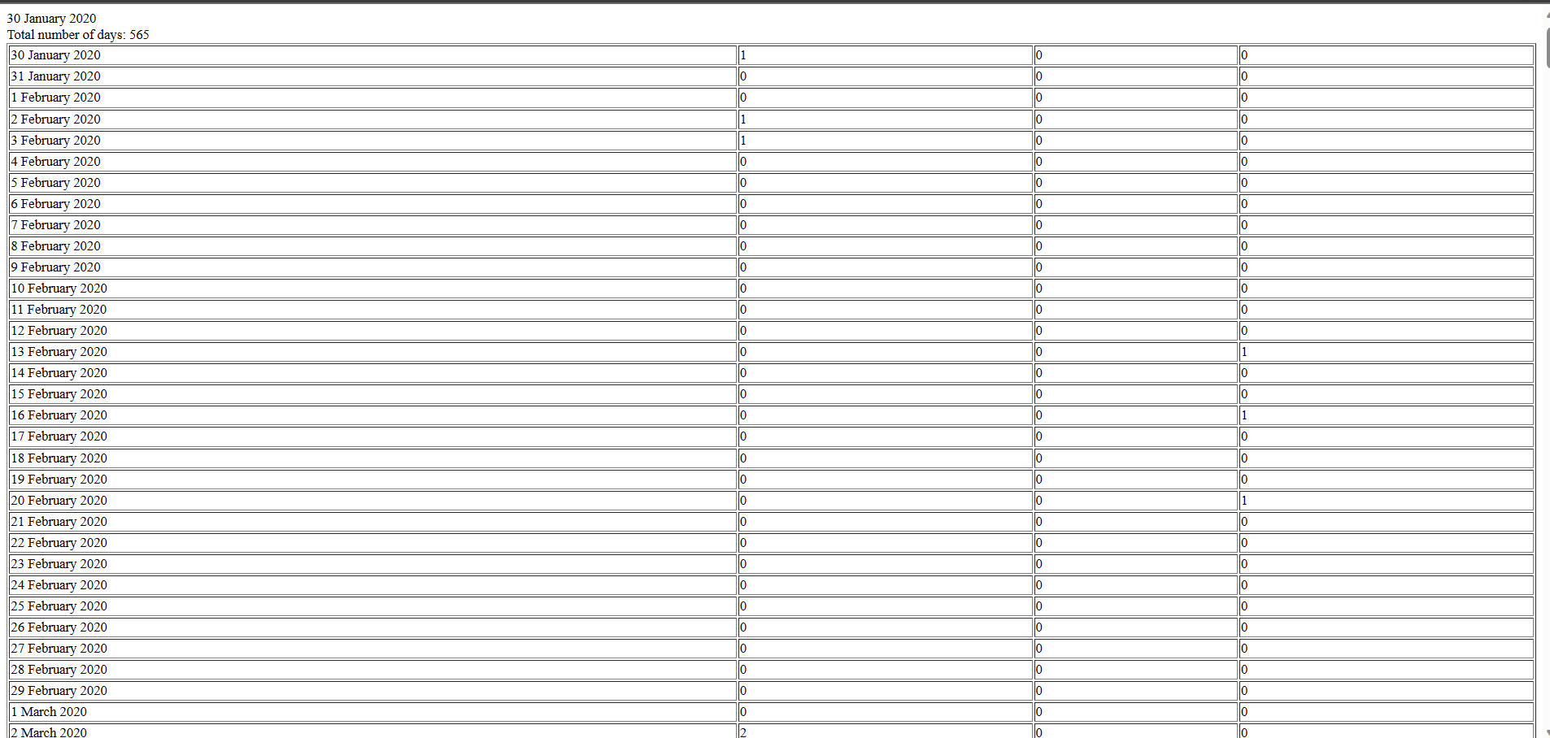**Output:**

**Fig3.2 Output**

**USER INPUT 1: JS Pop Up Boxes**

* Popup boxes in JavaScript provide simple ways to interact with users:

1. **Alert:** Shows a message with an OK button for displaying information.

Syntax: alert("Hello!");

1. **Confirm:** Displays a message with OK and Cancel buttons for user confirmation.

Syntax: const result = confirm("Continue?");

1. **Prompt:** Presents a message with an input field for user input.

Syntax: const userInput = prompt("Enter your name:");

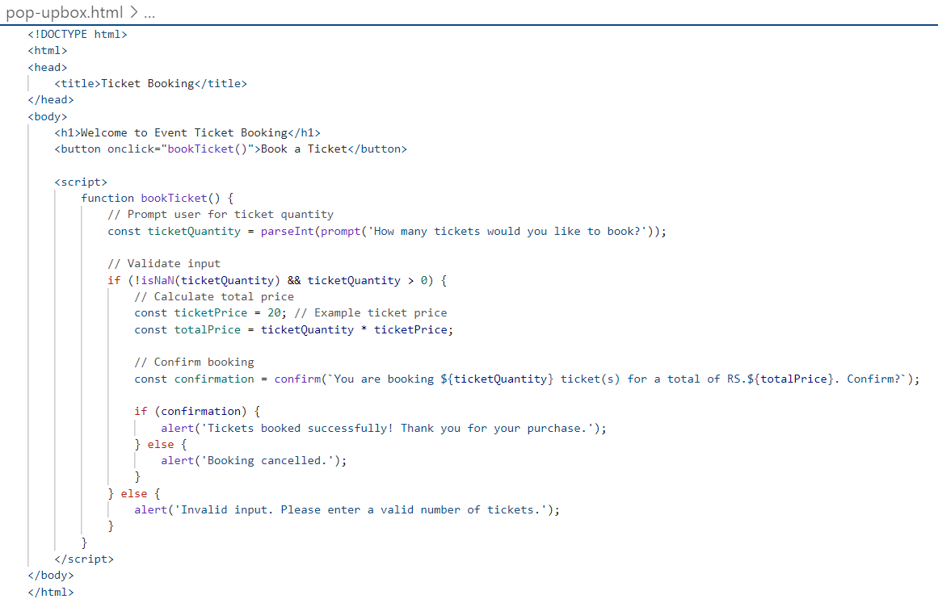

**Fig3.3 Pop-upbox.html**

**Output:**

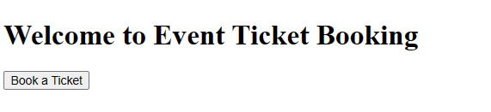

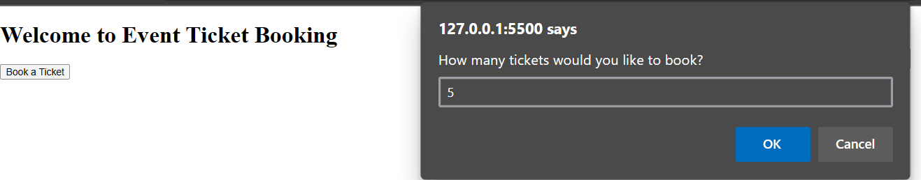

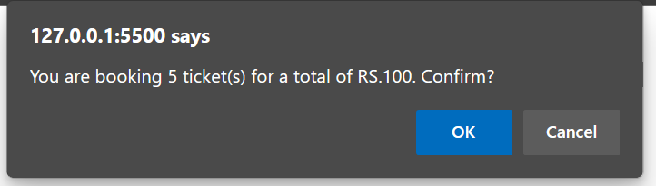

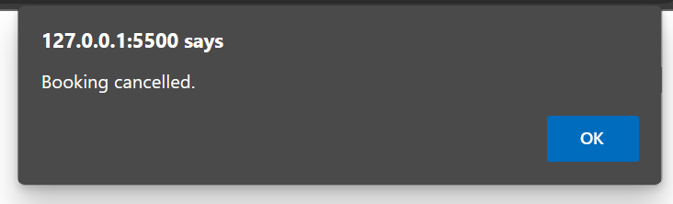

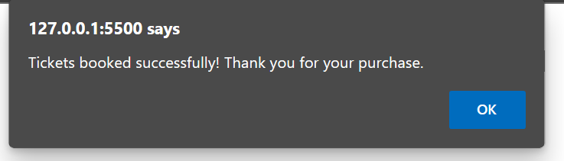

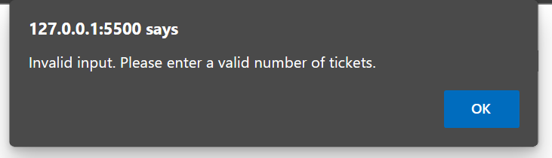

**Fig3.4 Output**

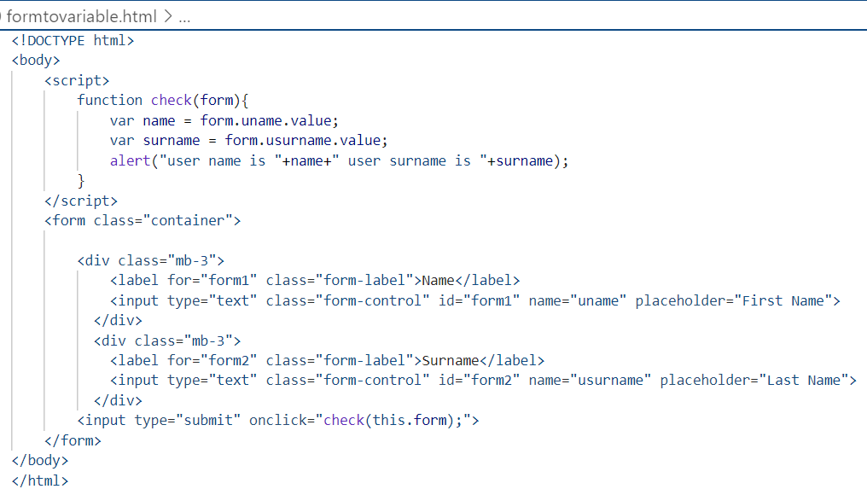**USER INPUT 2: Form to Variable**

**Fig3.5 Formtovariable.html**

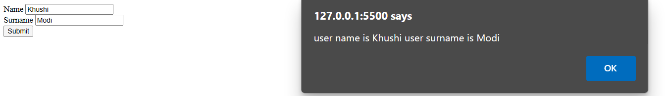**Output:**

**Fig3.6 Output**

**WEEK 1: 01 AUGUST 2023**

**Form to table**

<!DOCTYPE html>

<html>

<head>

  <title>Form Data to Table</title>

</head>

<body>

    <script>

        function showdata(form){

            var name = form.uname.value;

            var password = form.upassword.value;

            var city = form.ucity.value;

            if(name=="" || password=="" || city==""){

                document.getElementById("msg").innerHTML = "Fields can not be blank";

            }

            else{

                document.getElementById("msg").innerHTML = "<table border='1' width='500px'><tr><td>Name: </td><td>" +name+ "</td></tr><tr><td>Password: </td><td>" +password+ "</td></tr><tr><td>City : </td><td>" +city+ "</td></tr></table>";

            }

        }

    </script>

    <form>

        <div>

            <label for="form1" class="form-label">Name</label>

            <input type="text" class="form-control" id="form1" name="uname" placeholder="Name">

        </div>

        <br>

        <div>

            <label for="Password" class="form-label">Password</label>

            <input type="password" class="form-control" name="upassword" id="Password" placeholder="Password">

        </div>

        <br>

        <select class="form-select" name="ucity">

            <option selected>City</option>

            <option value="ADI">Ahmedabad</option>

            <option value="MEH">Mehsana</option>

            <option value="RAJ">Rajkot</option>

        </select>

        <br>

        <div>

            <button type="submit" class="btn btn-primary" onclick="showdata(this.form); return false;">Submit</button>

        </div>

    </form>

    <p id="msg"></p>

</body>

</html>

**Output:**

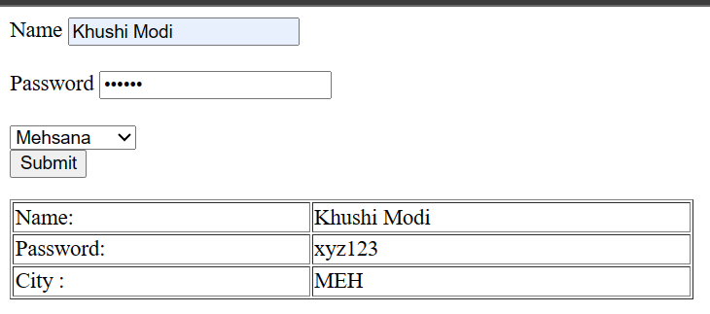

**Fig4.1 Formtotable outpot**

**JS Arrays**

<!DOCTYPE html>

<body>

    <script>

        //basic array concepts

        var mydata = [10,20,30,40,50,60];

        document.write(mydata+"<br>");

        document.write(mydata+"<br>");

        document.write(mydata[0]+"<br>");

        document.write(mydata[3]+"<br>");

        document.write(mydata[-3]+"<br>");

        document.write("Total number of elements : ",mydata.length+"<br>");

        //add the data at the end

        mydata.push(70);

        document.write(mydata);

        var emails = ["abc.com", "xyz.com", "pqr.com"];

        var password = ["abc123", "xyz123", "pqr123"];

        function login(form){

            var useremail = form.uemail.value;

            var userpassword = form.upassword.value;

            if(useremail=="" || userpassword==""){

                if(useremail=="" && userpassword !=""){

                    document.getElementById("msg").innerHTML = "Email Field can not be blank";

                }

                else if(useremail !="" && userpassword==""){

                    document.getElementById("msg").innerHTML = "Password Field can not be blank";

                }

                else{

                    document.getElementById("msg").innerHTML = "both Fields are required.";

                }

            }

            else{

                for(var i=0; i<emails.length; i++){

                    if(useremail==emails[i] && userpassword==password[i]){

                        document.getElementById("msg").innerHTML = "<font style='color:green'>Login Successful</font>";

                            break;

                    }

                    else{

                            document.getElementById("msg").innerHTML = "<font style='color:red'>Invalid username or password</font>";

                    }

                }

            }

        }

    </script>

    <form>

        Email : <input type="email" name="uemail"><br>

        Password : <input type="password" name="upassword"><br>

        <input type="submit" onclick="login(this.form); return false;">

    </form>

    <p id="msg"></p>

</body>

</html>

**Output:**

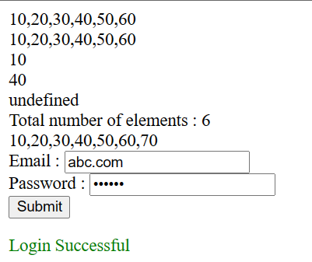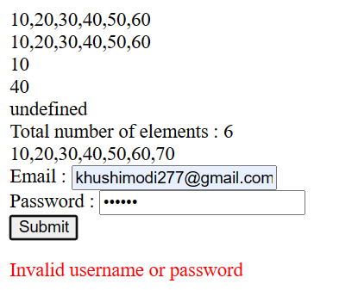

**Fig4.2 Array outpot**

**WEEK 1: 02 AUGUST 2023**

**Task Assignment**

1. **Covid Data Search**

<!DOCTYPE html>

<html>

<head>

    <link rel="stylesheet" href="https://maxcdn.bootstrapcdn.com/bootstrap/3.4.1/css/bootstrap.min.css">

</head>

<body>

    <h1>COVID-19 India Data</h1>

    <input type="text" id="inputDate" placeholder="Enter date (dd-mm-yyyy)">

    <button onclick="load()">Submit</button>

    <p id="msg"></p>

    <table class="table table-striped" id="dataTable">

        <tr>

        </tr>

    </table>

    <script>

        async function load() {

            const inputDate = document.getElementById('inputDate').value;

            const outputTableElement = document.getElementById('msg');

            const dataTable = document.getElementById('dataTable');

            if (!inputDate) {

                outputTableElement.innerText = "Please enter a date instead of table.";

                return;

            }

            var url = "https://data.covid19india.org/data.json";

            var myobject = await (await fetch(url)).json();

            const casesData = myobject.cases_time_series; // Corrected property access

            let dateFound = false;

            for (let i = 0; i < casesData.length; i++) {

                if (casesData[i].date === inputDate) {

                    dateFound = true;

                    outputTableElement.innerText = "";

                    dataTable.innerHTML = `

                        <tr>

                            <td>New Cases</td>

                            <td>${casesData[i].dailyconfirmed}</td>

                        </tr>

                        <tr>

                            <td>New Deaths</td>

                            <td>${casesData[i].dailydeceased}</td>

                        </tr>

                    `;

                    break;

                }

            }

            if (!dateFound) {

                outputTableElement.innerText = "Date not found instead of table.";

            }

        }

    </script>

</body>

</html>

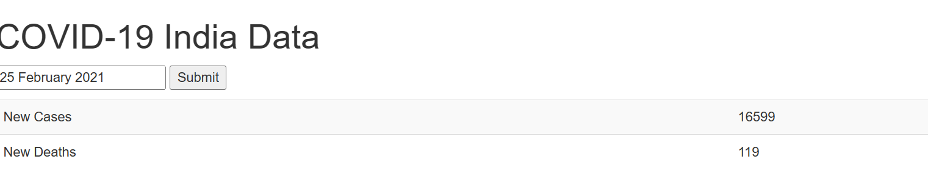**Output:**

**Fig5.1 Covid data search outpot**

1. **Mutual Fund API**

<!DOCTYPE html>

<html lang="en">

<head>

    <link href="https://cdn.jsdelivr.net/npm/bootstrap@5.3.1/dist/css/bootstrap.min.css" rel="stylesheet"

        integrity="sha384-4bw+/aepP/YC94hEpVNVgiZdgIC5+VKNBQNGCHeKRQN+PtmoHDEXuppvnDJzQIu9" crossorigin="anonymous">

</head>

<body>

    <script>

        async function clickHandle(form) {

            var scode = form.scode.value;

            if (scode == "") {

                document.getElementById("msg").innerHTML = "<span class='text-danger'>Please enter the <strong>Scheme Code</strong></span>";

            } else {

                let url = "https://api.mfapi.in/mf";

                let myMFData = await (await fetch(url)).json();

                for (let j = 0; j < myMFData.length; j++) {

                    if (myMFData[j]["schemeCode"] == scode) {

                        console.log(1);

                        document.getElementById("msg").innerHTML = "<span class='text-success'><strong>" + myMFData[j]["schemeName"] + "</strong></span>";

                        break;

                    } else {

                        console.log(2);

                        document.getElementById("msg").innerHTML = `<strong class='text-danger'>The entered Scheme code ${scode} not found</strong>`;

                    }

                }

                document.getElementById("totalScheme").innerHTML = "<span class='text-primary'>The total number of Scheme available in this API is <strong>" + myMFData.length + "</strong></span>";

            }

        }

    </script>

    <div class="container my-2 text-center">

        <h2> Mutual Fund Data</h2>

        <h5>Take the scheme code from the user and print scheme name</h5>

        <form>

            <div class="mb-3 ms-auto me-auto" style="width: 50%">

                <label for="scode" class="form-label"><strong>Scheme Code</strong></label>

                <input type="number" class="form-control" name="scode" id="scode" required>

            </div>

            <div class="ms-auto me-auto" style="width: 10%;">

                <button type="button" class="btn btn-primary" onclick="clickHandle(this.form);">Show Fund</button>

            </div>

            <p id="msg" class="my-3"></p>

            <p id="totalScheme"></p>

        </form>

    </div>

</body>

</html>

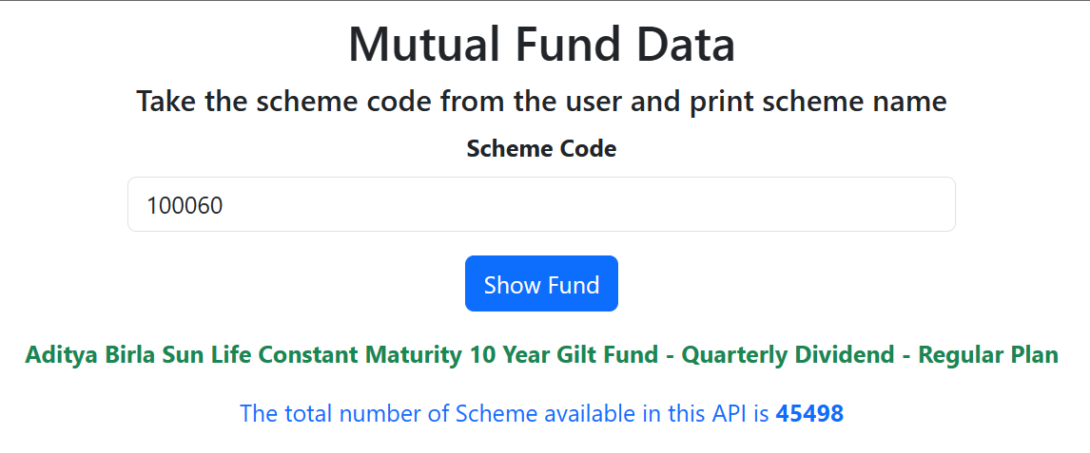**Output:**

**Fig5.2 Mutual fund API outpot**

**WEEK 2: 03 AUGUST 2023**

**React Environment setup ( Node JS installation )**

* Here's a short guide on setting up a React environment by installing Node.js:

1. **Install Node.js:**

* Go to the official Node.js website: https://nodejs.org/
* Download the LTS (Long Term Support) version for your operating system (Windows, macOS, Linux).
* Run the installer and follow the on-screen instructions.

1. **Verify Installation:**
   * Open a terminal (Command Prompt on Windows) and type:

node -v

* + You should see the version number of Node.js printed.

1. **NPM(Node Package Manager):**
   * npm is installed along with Node.js. You can verify it by typing:

npm -v

* + You should see the version number of npm printed.

1. **Create a React App**:
   * Once you have Node.js and npm installed, you can create a new React app using `create-react-app`, which is a tool that sets up a new React project with the necessary files and configuration.
   * In your terminal, run:

npx create-react-app my-react-app

* + Replace `my-react-app` with your preferred project name.

1. **Navigate to Your Project:**
   * Change your working directory to the newly created app:

cd my-react-app

1. **Start the Development Server:**
   * To start a development server and see your React app in action, run:

npm start

* + This will start the development server, and your default web browser will open, displaying your React app.

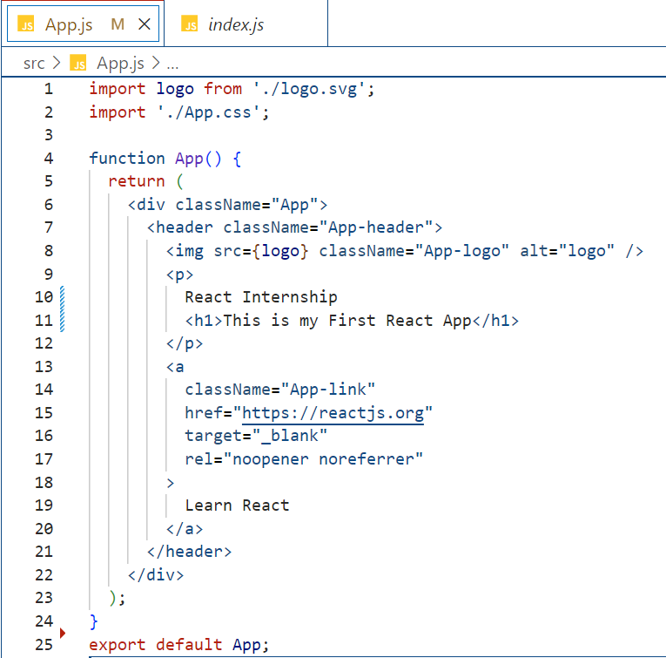**First React App**

**Fig6.1** **First React App**

**Output:**

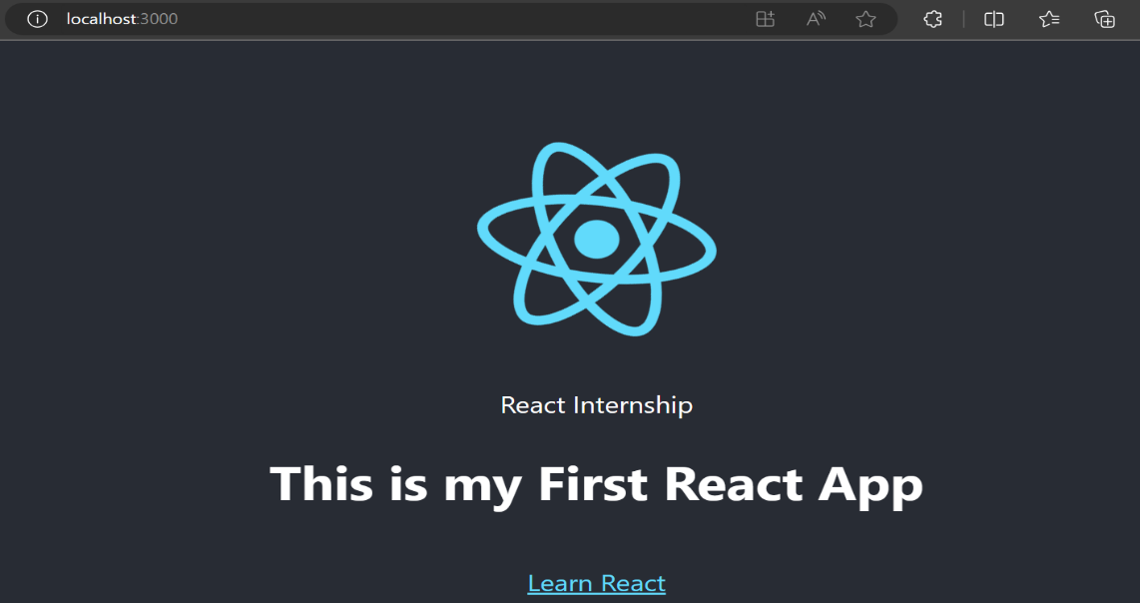

**Fig6.2 Output**

**Functional Components**

* Functional Components in React are a way to create reusable UI elements using JavaScript functions.
* 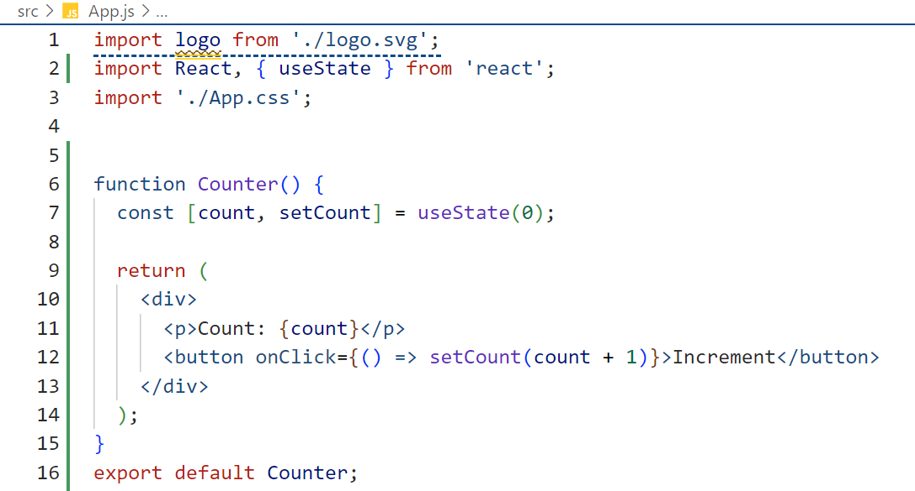They are a core concept in React and provide a simpler way to define components compared to class components.

**Fig6.3 Functional Component**

**Class Components**

* Class Components are another way to create reusable and dynamic UI elements in React.
* They were the primary way of creating components in React before the introduction of functional components and hooks.
* Class components have methods like `render()`, `componentDidMount()`, `componentDidUpdate()`, and more, which allow you to control the component's lifecycle and behavior.

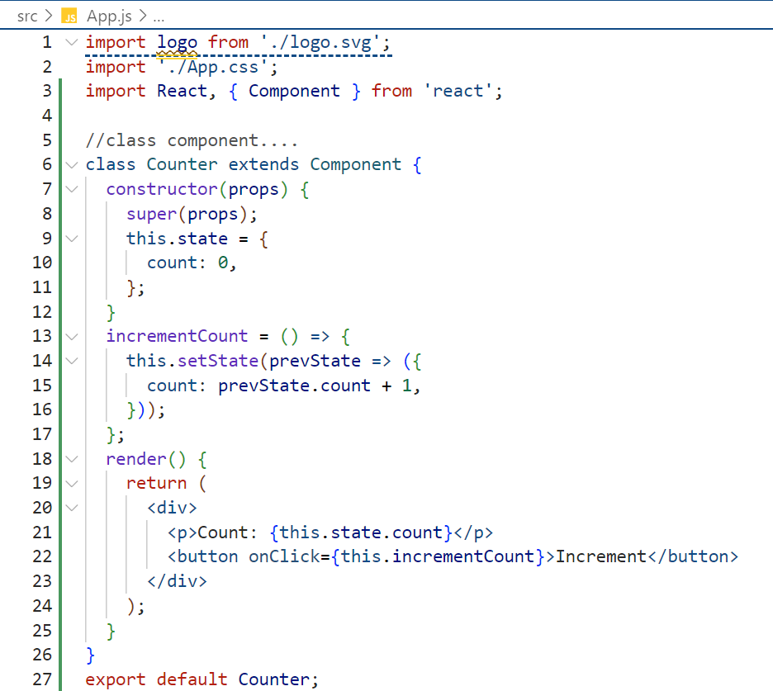

**Fig6.4 Functional Component**

**Output:**

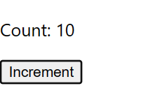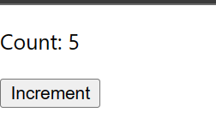

**Fig6.5 Output**

**WEEK 2: 04 AUGUST 2023**

**Variable Data Map**

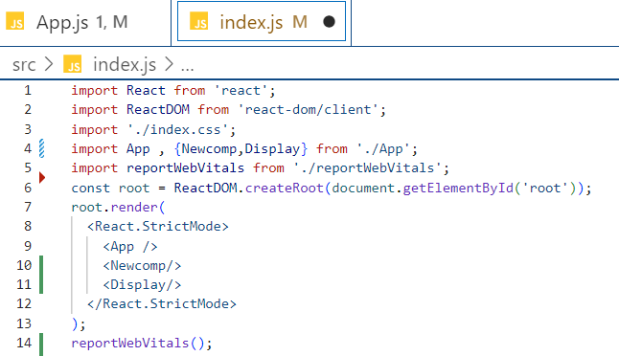

**Fig7.1 Map**

**Output:**

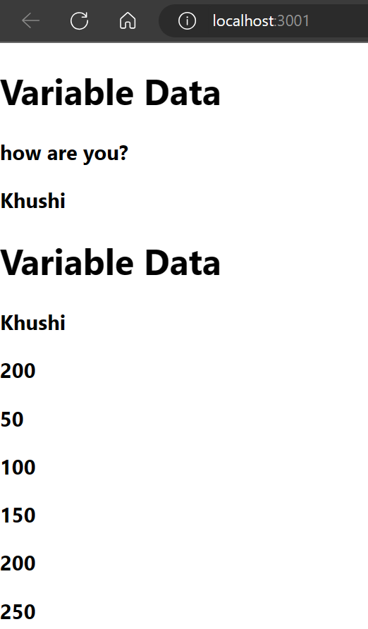

**Fig7.2 Output**

**Object Map**

**App.js**

import logo from './logo.svg';

import './App.css';

function App() {

  return (

    <div>

      <h1>Object Data Map</h1>

    </div>

  );

}

const data = {"KEY1":"Value1","KEY2":"Value2"};

function Datashow(){

  return(

    <div>

    {

      Object.keys(data).map(

        (items,i) => {

          return <h4>{items} and {data[items]}</h4>

        }

      )

    }

    </div>

  );

}

const isrodata = {

  "spacecrafts": [

      {

          "id": 1,

          "name": "Aryabhata"

      },

      {

          "id": 2,

          "name": "Bhaskara-I"

      },

      {

          "id": 3,

          "name": "Rohini Technology Payload (RTP)"

      },

      {

          "id": 4,

          "name": "Rohini Satellite RS-1"

      },

      {

          "id": 5,

          "name": "Rohini Satellite RS-D1"

      },

  ]

}

function IsroTable() {

  return (

    <div>

      {

        isrodata.spacecrafts.map(

          (value) => {

            return <h4>{value.id} and {value.name}</h4>

          }

        )

      }

    </div>

  );

}

export default App;

export {Datashow,IsroTable};

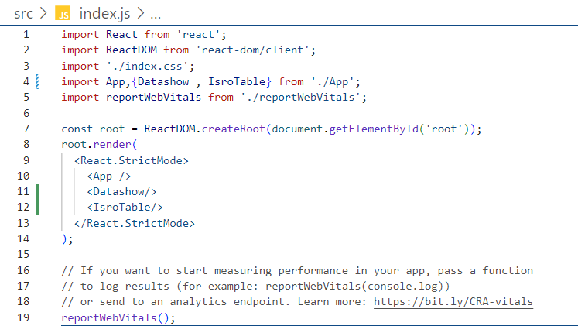

**Fig7.3 Object Map**

**Output:**

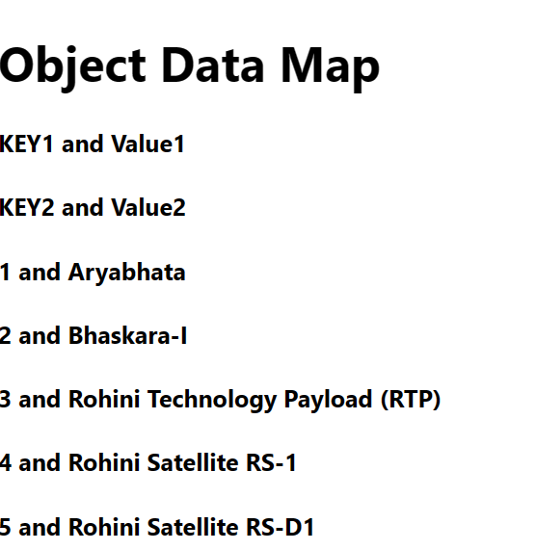

**Fig7.4 Output**

**WEEK 2: 07 AUGUST 2023**

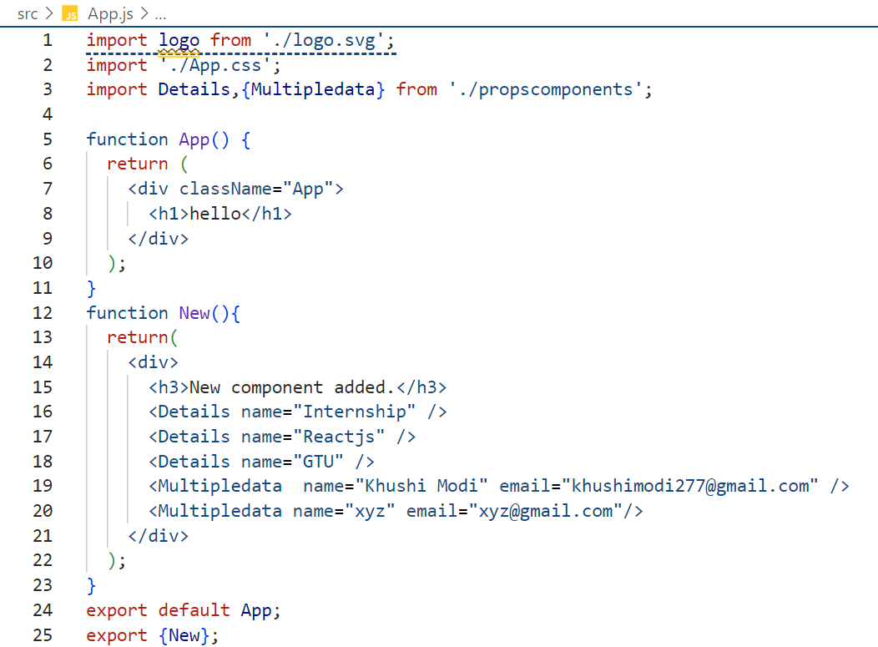**React Props**

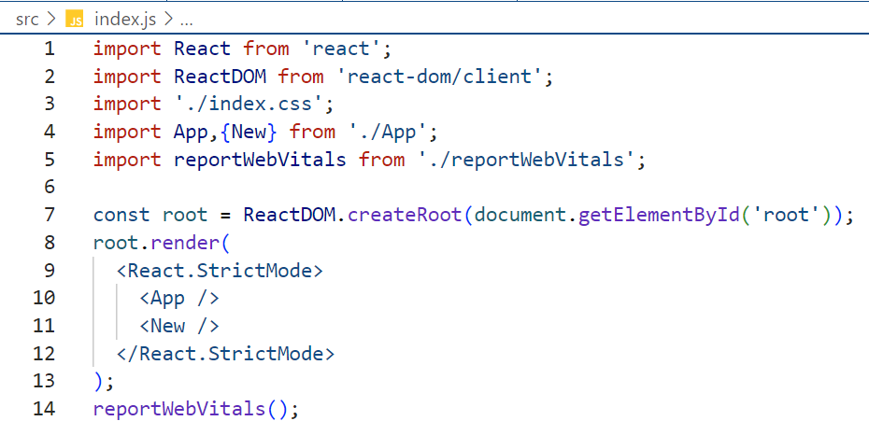

**Fig8.1 React Props**

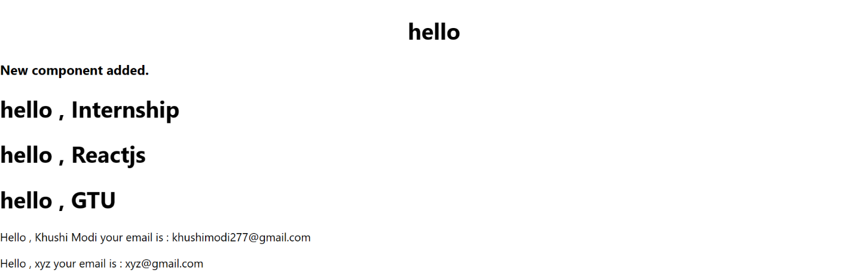**Output:**

**Fig8.2 Output**

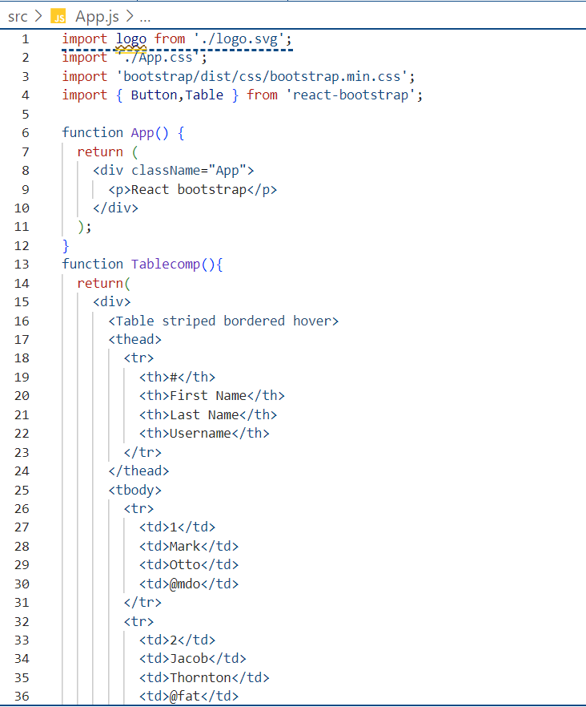**React Bootstrap**

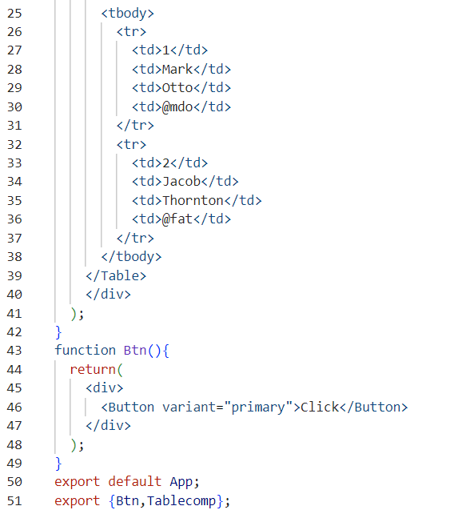

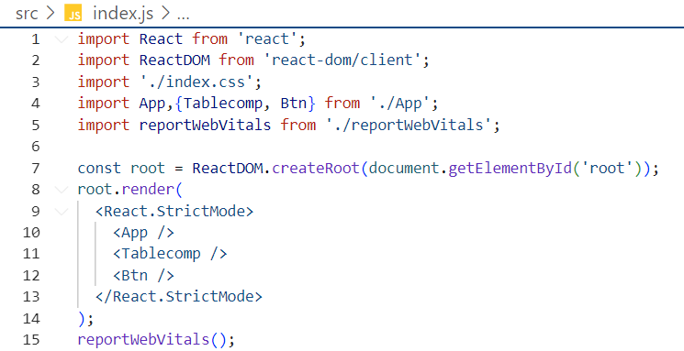

**Fig8.3 React Bootstrap**

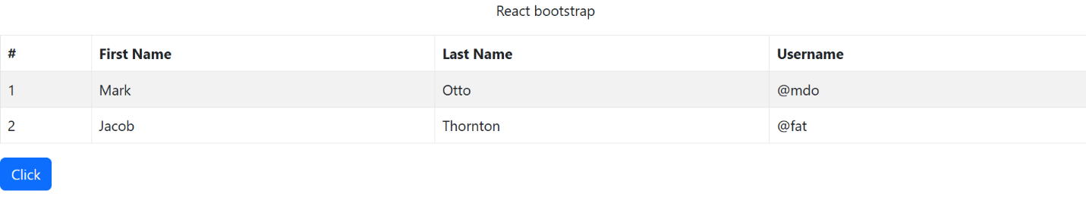**Output:**

**Fig8.4 Output**

**WEEK 2: 08 AUGUST 2023**

**React Hooks : UseEffect and UseState**

* Certainly! React Hooks, specifically `useState` and `useEffect`, are essential for managing state and side effects in functional components. Here's an explanation of each hook:

1. **useState:**

* The `useState` hook allows you to add state to your functional components.
* It returns a state variable and a function to update that variable.
* When the state is updated, React re-renders the component, reflecting the updated state.

1. **useEffect:**

* The `useEffect` hook is used to perform side effects in functional components, such as data fetching, DOM manipulation, and subscribing to external services.
* It is similar to lifecycle methods in class components.

**API data fetch with react**

**Example:**

**App.js**

import logo from './logo.svg';

import './App.css';

import { Container, Row, Col, Card, Table } from 'react-bootstrap';

import 'bootstrap/dist/css/bootstrap.min.css';

import React, { useState, useEffect } from 'react';

function App() {

  const [mydata, setData] = useState([]);

  const apiget = () => {

    fetch('https://inshortsapi.vercel.app/news?category=politics')

      .then((response) => response.json())

      .then((json) => {

        console.log(json);

        setData(json);

        setData(json.data)

      });

  };

  useEffect(() => {

    apiget();

    const interval = setInterval(() => { apiget(); }, 500000);

    return () => clearInterval(interval);

  }, []);

  return (

    <Container fluid>

      <Row xs={1} md={3} className="g-4">

        {

          mydata.map(

            (value) => {

              return (

                <>

                  <Col className="container-fluid mt-4">

                    <Card border="info">

                        <Card.Title>{value.title}</Card.Title>

                      <Card.Img variant="top" src={value.imageUrl}style={{height: 350}} />

                      <Card.Body>

                        <Card.Title>{value.title}</Card.Title>

                        <Card.Text>

                          {value.content}

                        </Card.Text>

                        <footer className='blockquote-footer'>

                          published on : {value.date} , {value.time}

                        </footer>

                      </Card.Body>

                    </Card>

                  </Col>

                </>

              )

            }

          )

        }

      </Row>

    </Container>

  );

}

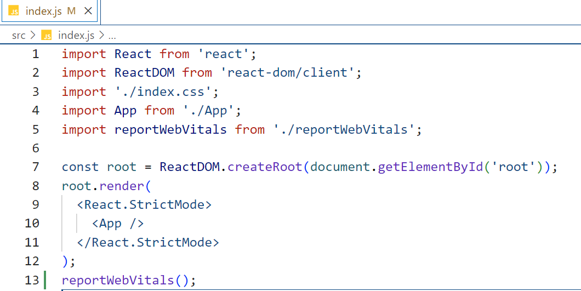export default App;

**Fig9.1 Fetch Politics Data**

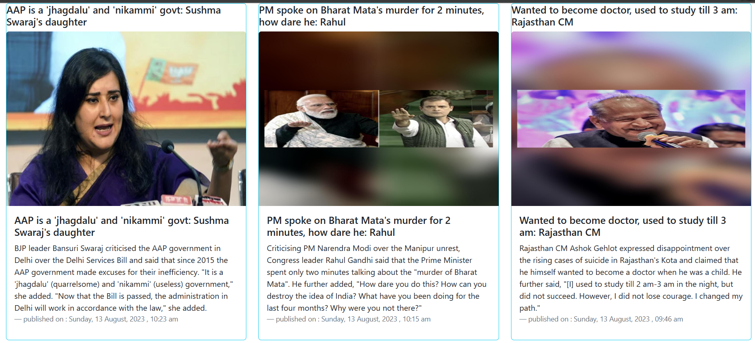**Output:**

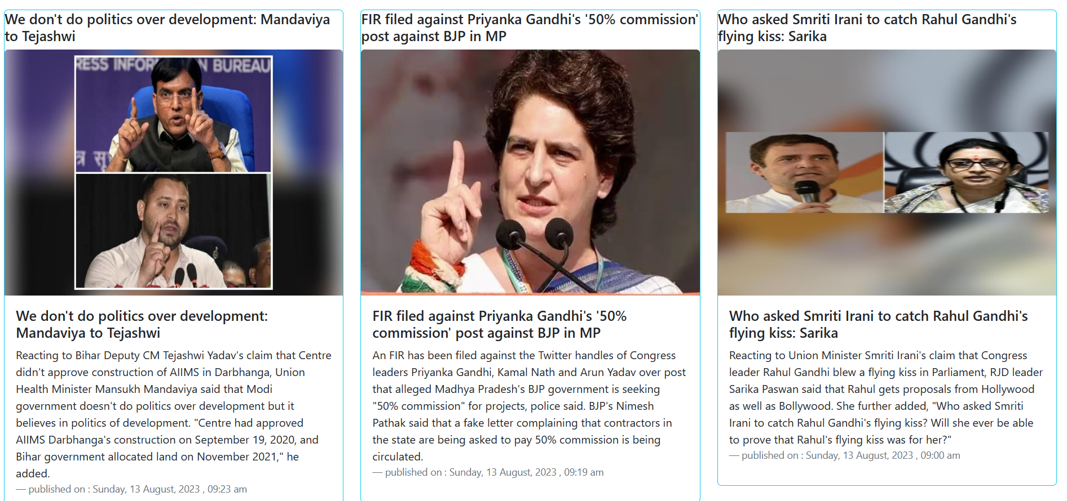

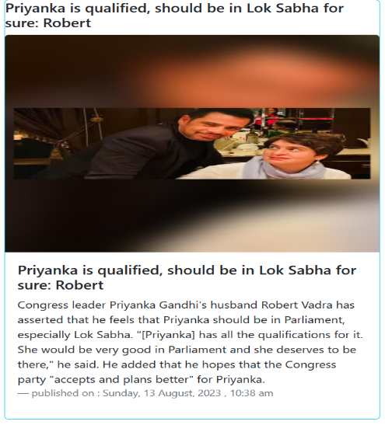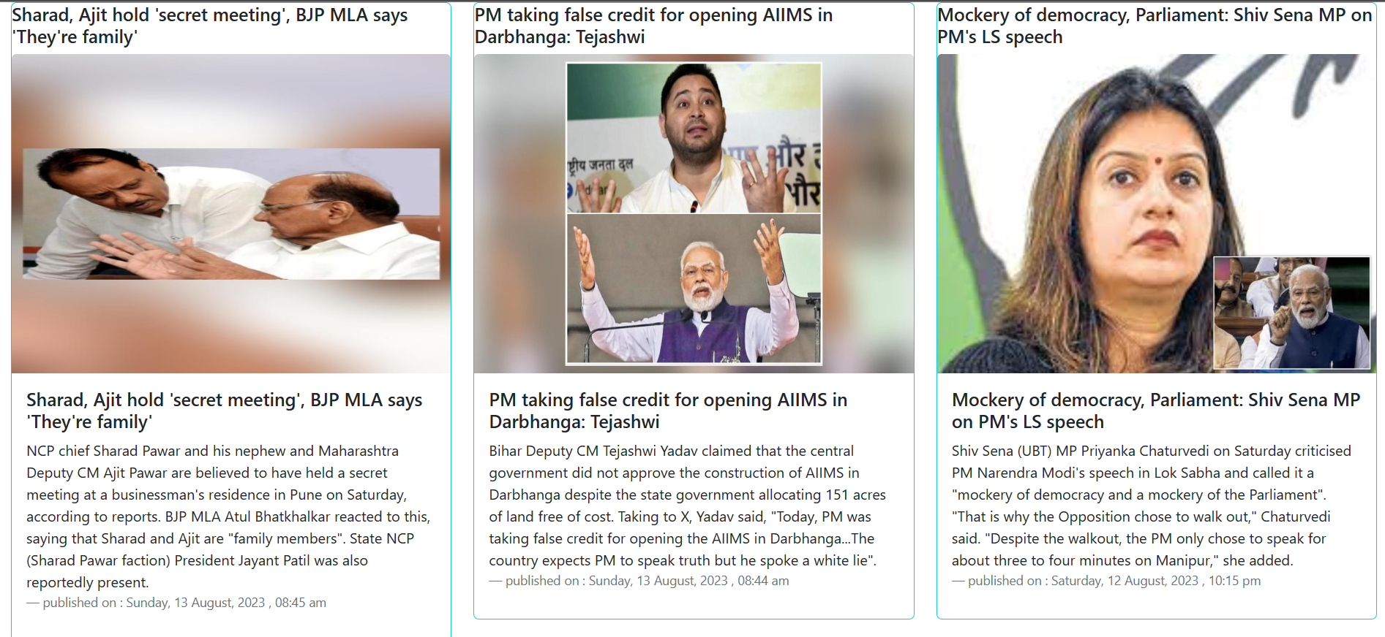

**Fig9.2 Output**

**WEEK 2: 09/10 AUGUST 2023**

**ASSIGNMENT -TASK (Project):**

**API BASED REAL TIME NEWS WEB APPLICATION**

**App.js**

import './App.css';

import React, { useState, useEffect } from 'react'

import 'bootstrap/dist/css/bootstrap.min.css';

import { Container, Card, Row, Col } from 'react-bootstrap';

const Cards = () => {

    const [myData, setData] = useState([]);

    const apiget = () => {

        fetch('https://inshortsapi.vercel.app/news?category=sports')

        .then((response) => response.json())

        .then((json) => {

            console.log(json);

            setData(json.data)

        });

    }

    useEffect(() => {

        apiget();

        const interval = setInterval(()=>{apiget();}, 50000);

        return () => clearInterval(interval);

    }, []);

    return (

        <Container fluid>

            <h3 className="text-center my-3">Project - Fetching the News from the API and Display it in the card format.</h3>

            <Row className='mt-4 g-4' xs={1} md={3}>

                    {

                        myData.map(

                            (value) => {

                                return (

                                    <>

                                    <Col>

                                        <Card>

                                            <Card.Img variant="top" src={value.imageUrl} style={{height: 350}} />

                                            <Card.Body>

                                                <Card.Title>{value.title}</Card.Title>

                                                <Card.Text>

                                                    {value.content}

                                                </Card.Text>

                                            </Card.Body>

                                            <Card.Footer>

                                                <small className="text-muted">{value.date} {value.time}</small>

                                            </Card.Footer>

                                        </Card>

                                        </Col>

                                    </>

                                )

                            }

                        )

                    }

            </Row>

        </Container>

    )

}

export default Cards

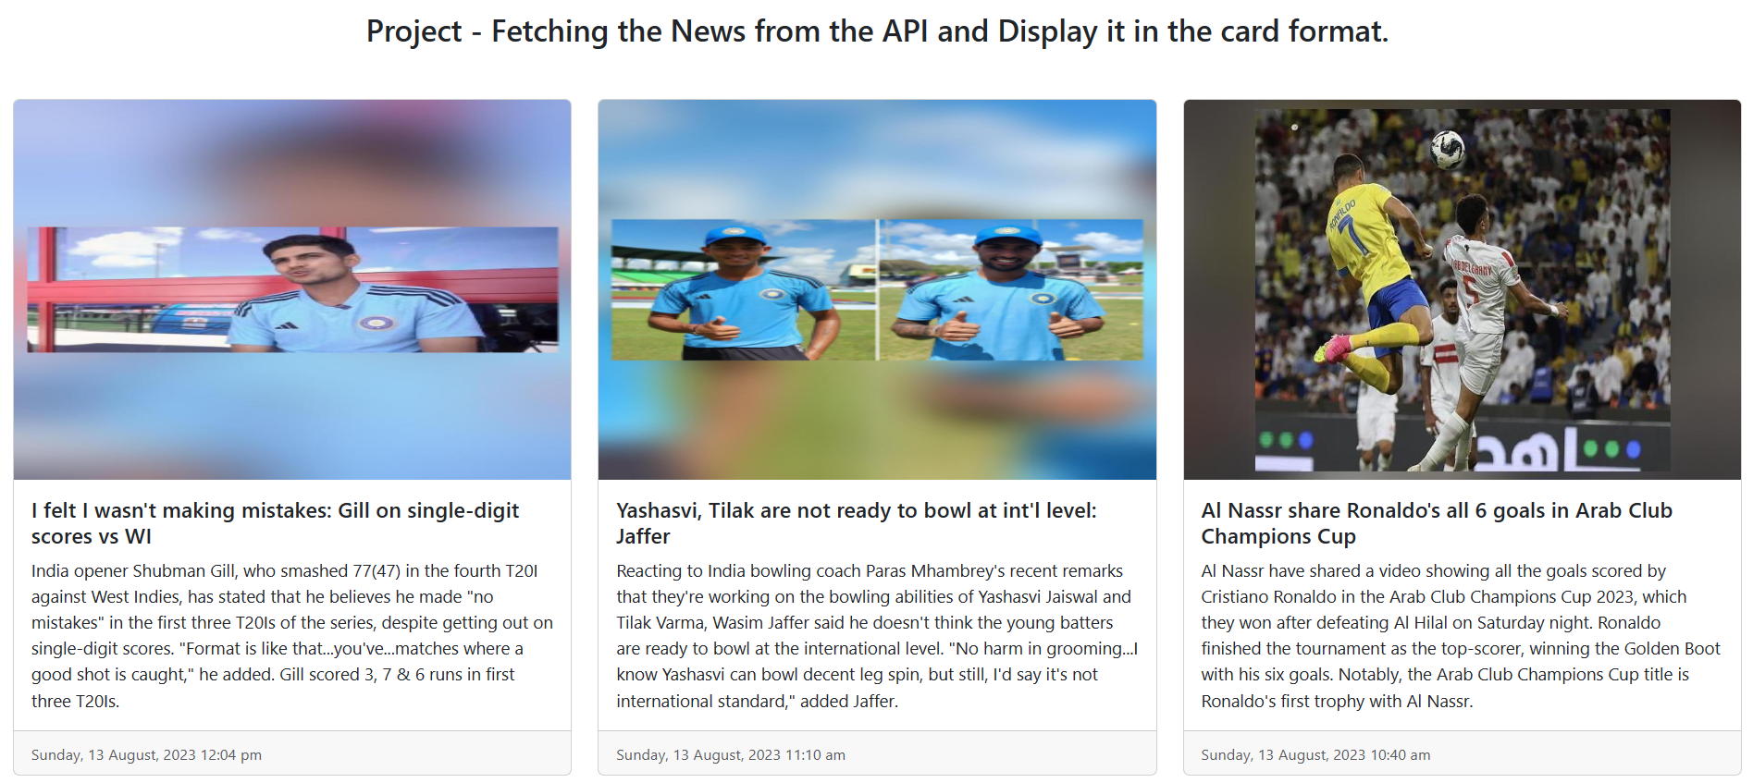**Output:**

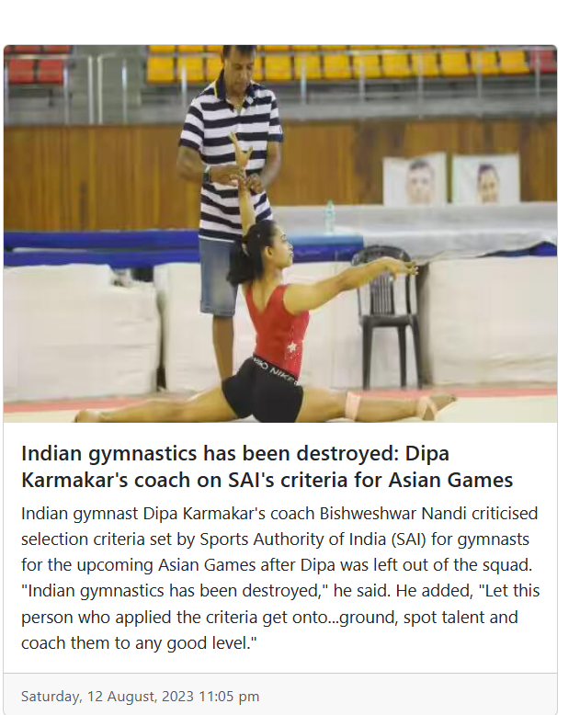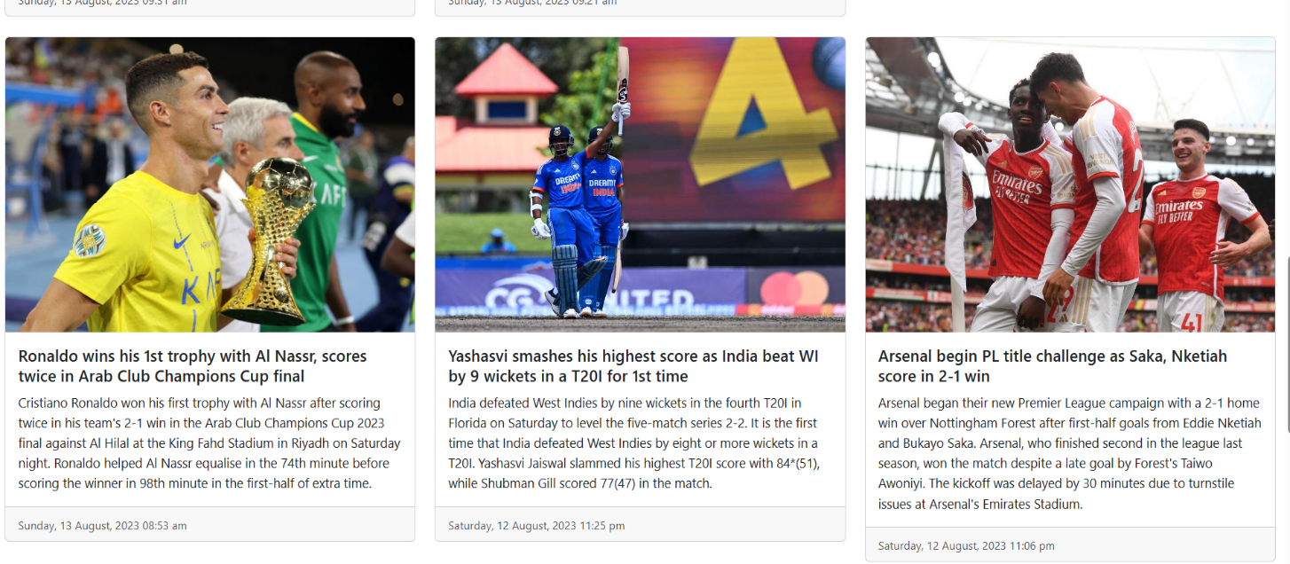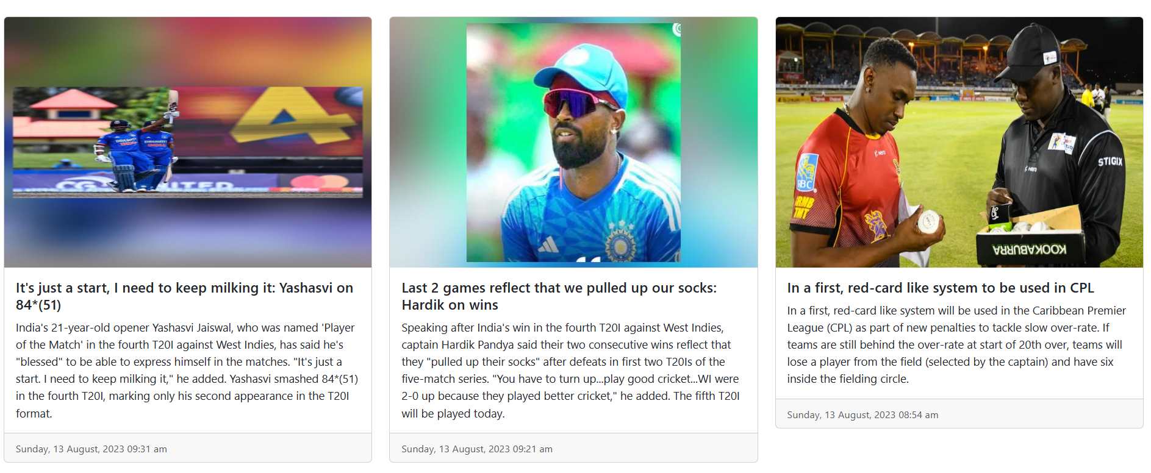

**Fig10.1 Sports Data Output**